Build And Release Management

Lab-3

Date: 04-02-21

**Name: RAJUL DUBEY**

**SAP ID: 500069424**

**ROLLNo.: R171218081**

**Task 1 ->** Create a simple MyCalc java

program

**Task 2->** Create A Junit Test Class

Goto new->goto new class -> JunitClass(not suit)

Run it as Junit (option near run as java application)

See it fails or not

Task 3-> give maven JUnit dependencies

In pom.xml

Now Create a build file through maven

Clean->install->test (goals)

Task 4-> Build Maven project (goal -> test)

**Task 1 ->** 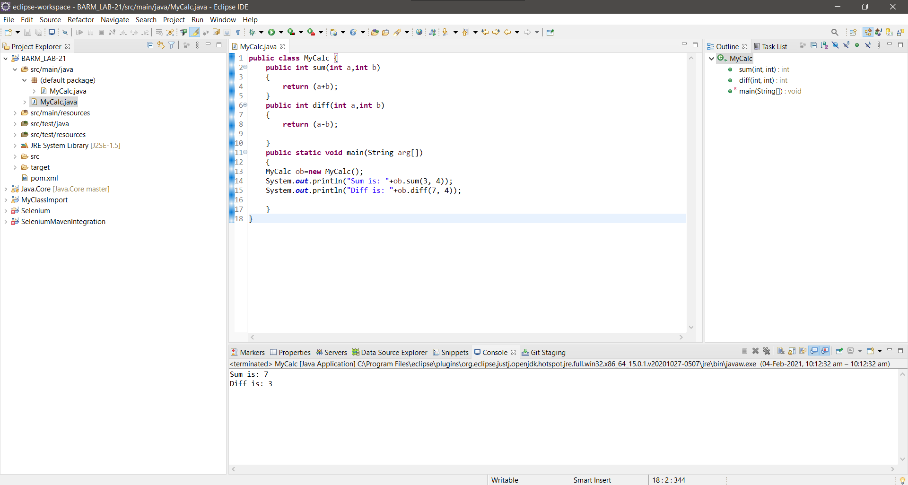

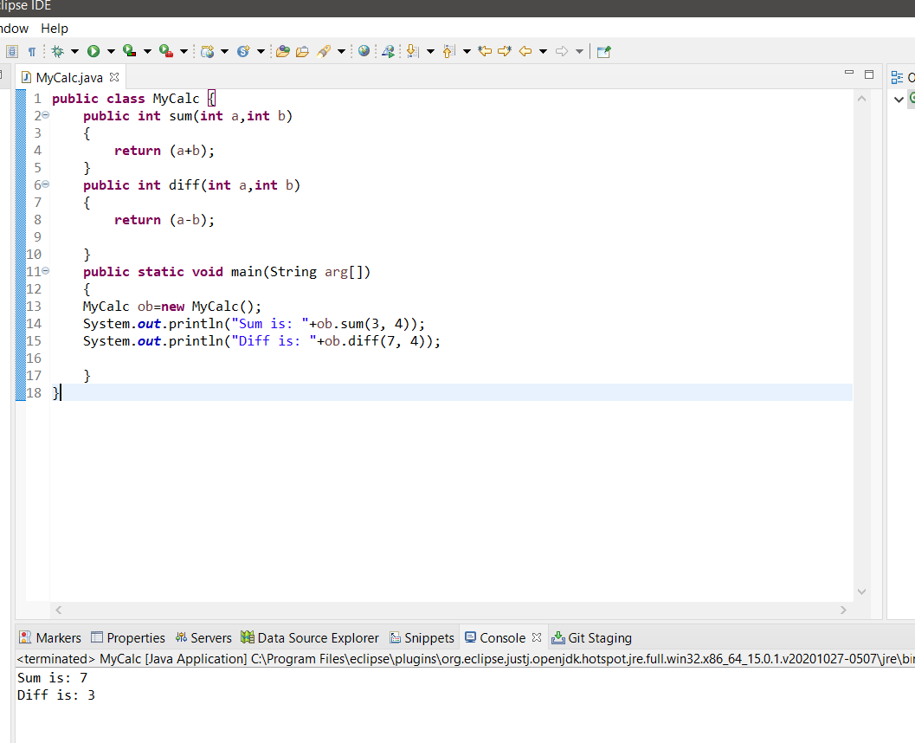

Task 2->

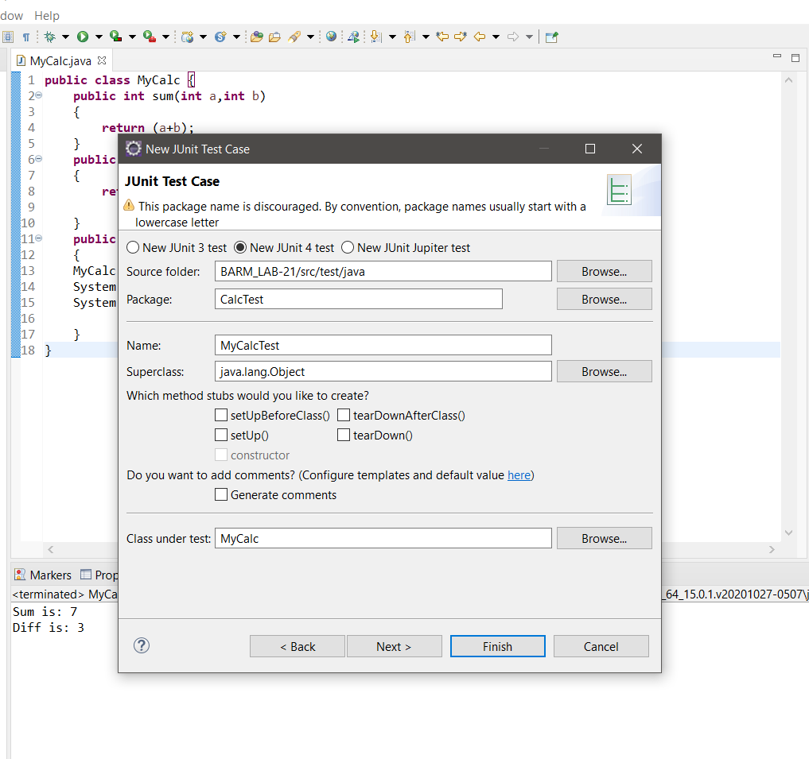

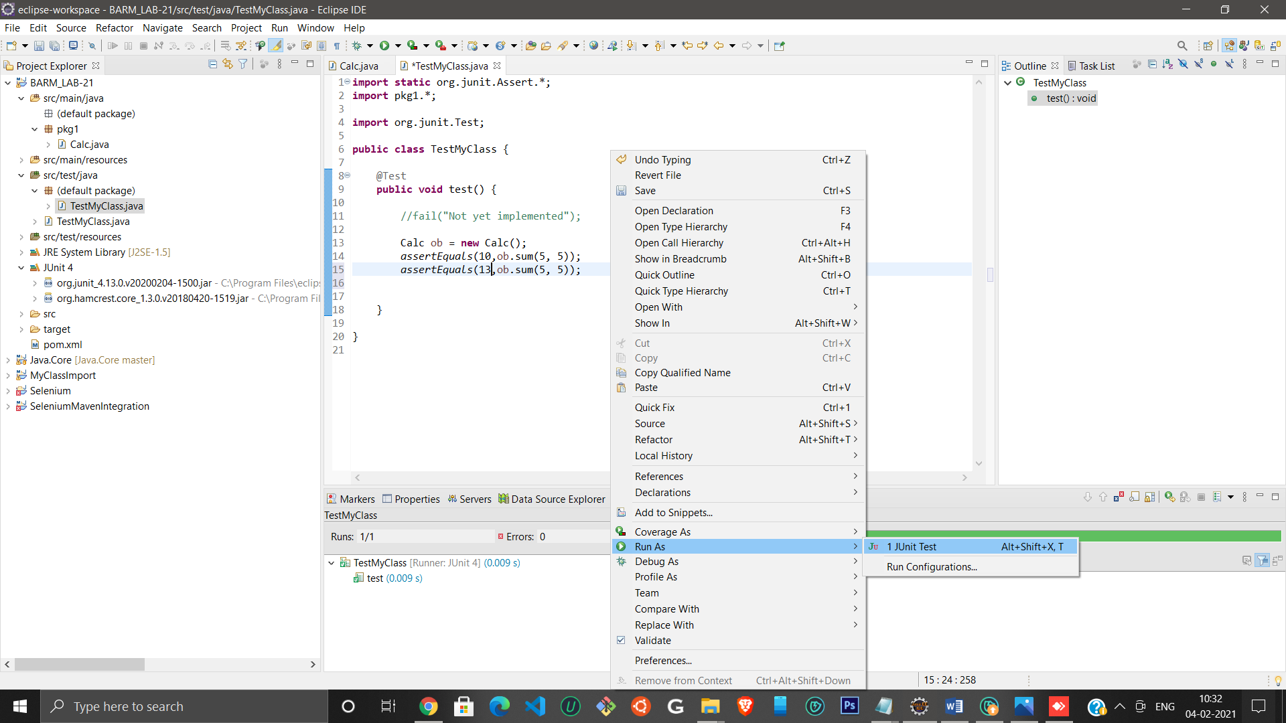

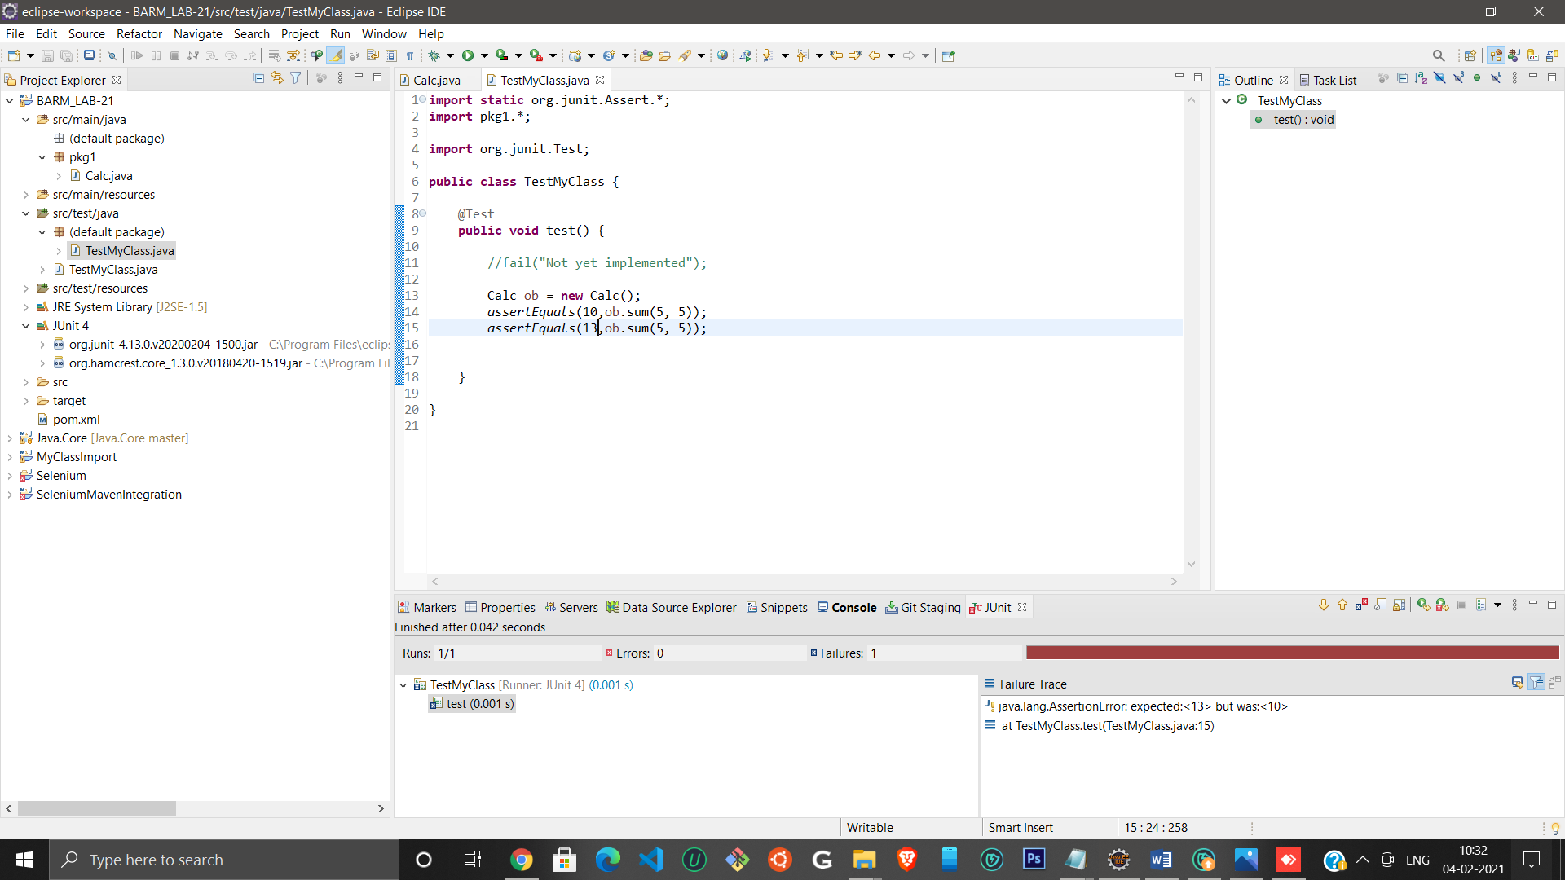

Task -> 3

Pom.xml Dependencies:

<dependencies>

<dependency>

  <groupId>junit</groupId>

  <artifactId>junit</artifactId>

  <version>4.13</version>

  <scope>test</scope>

</dependency>

</dependencies>

Task ->4

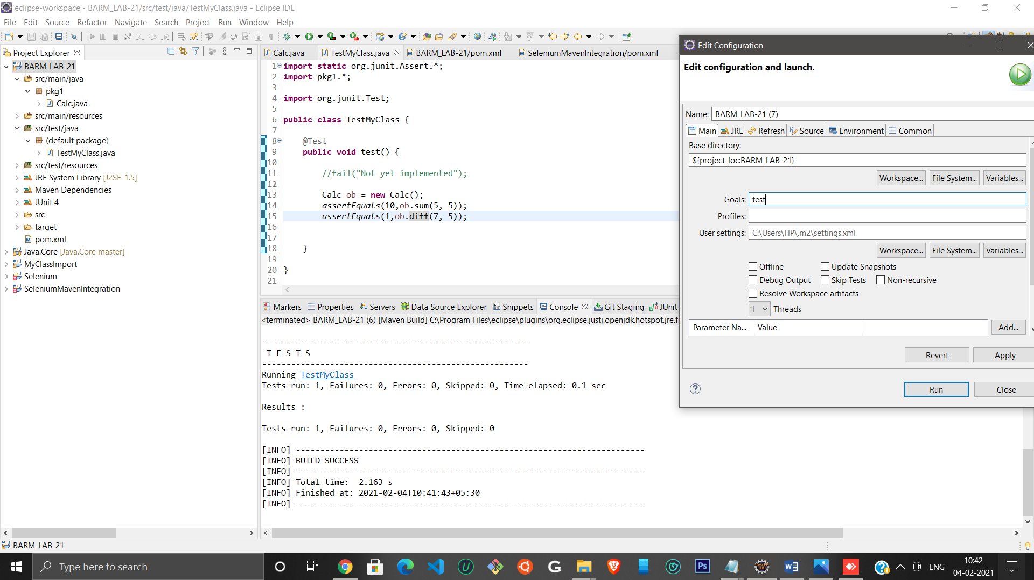

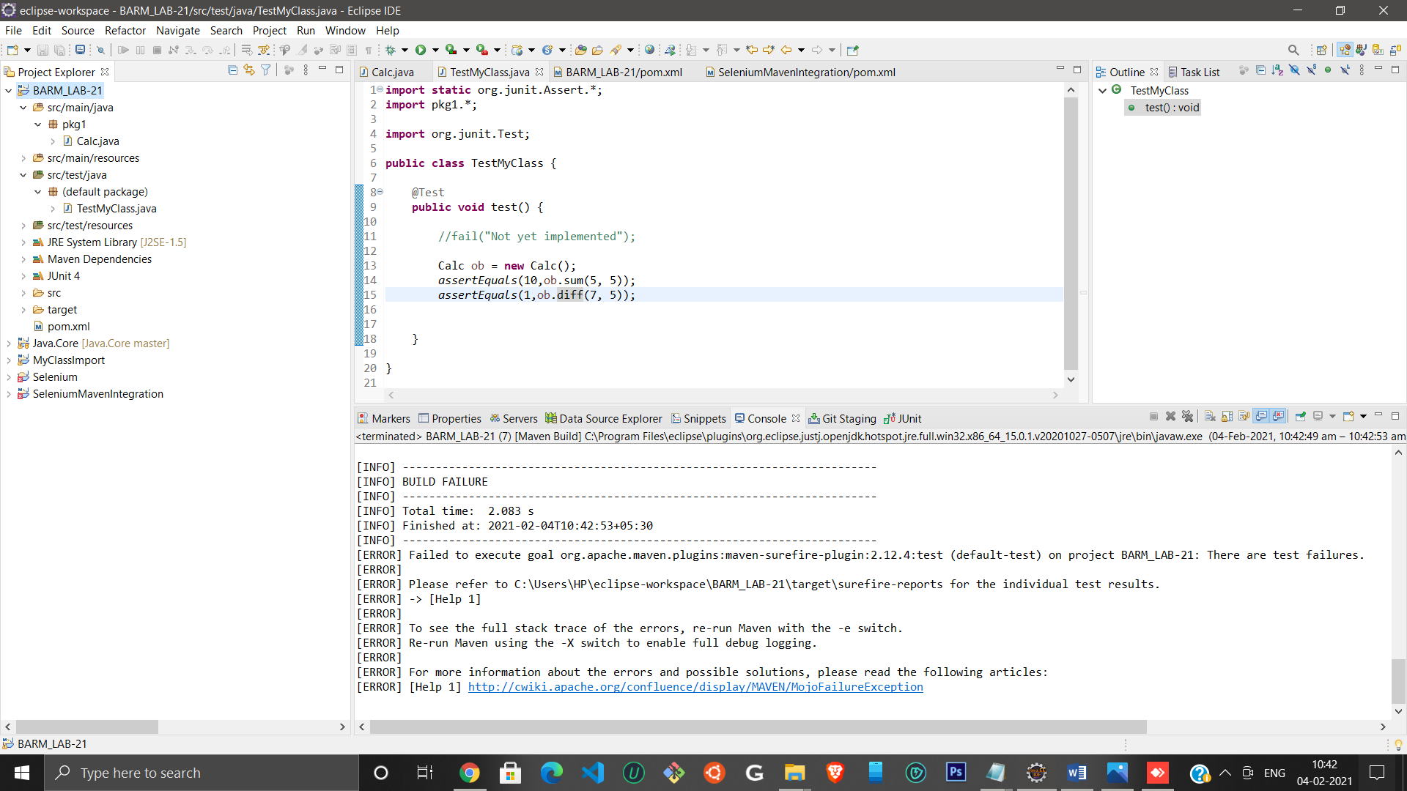

Note: If test condition failed in JUnit test then test (goal) will get a build failure.

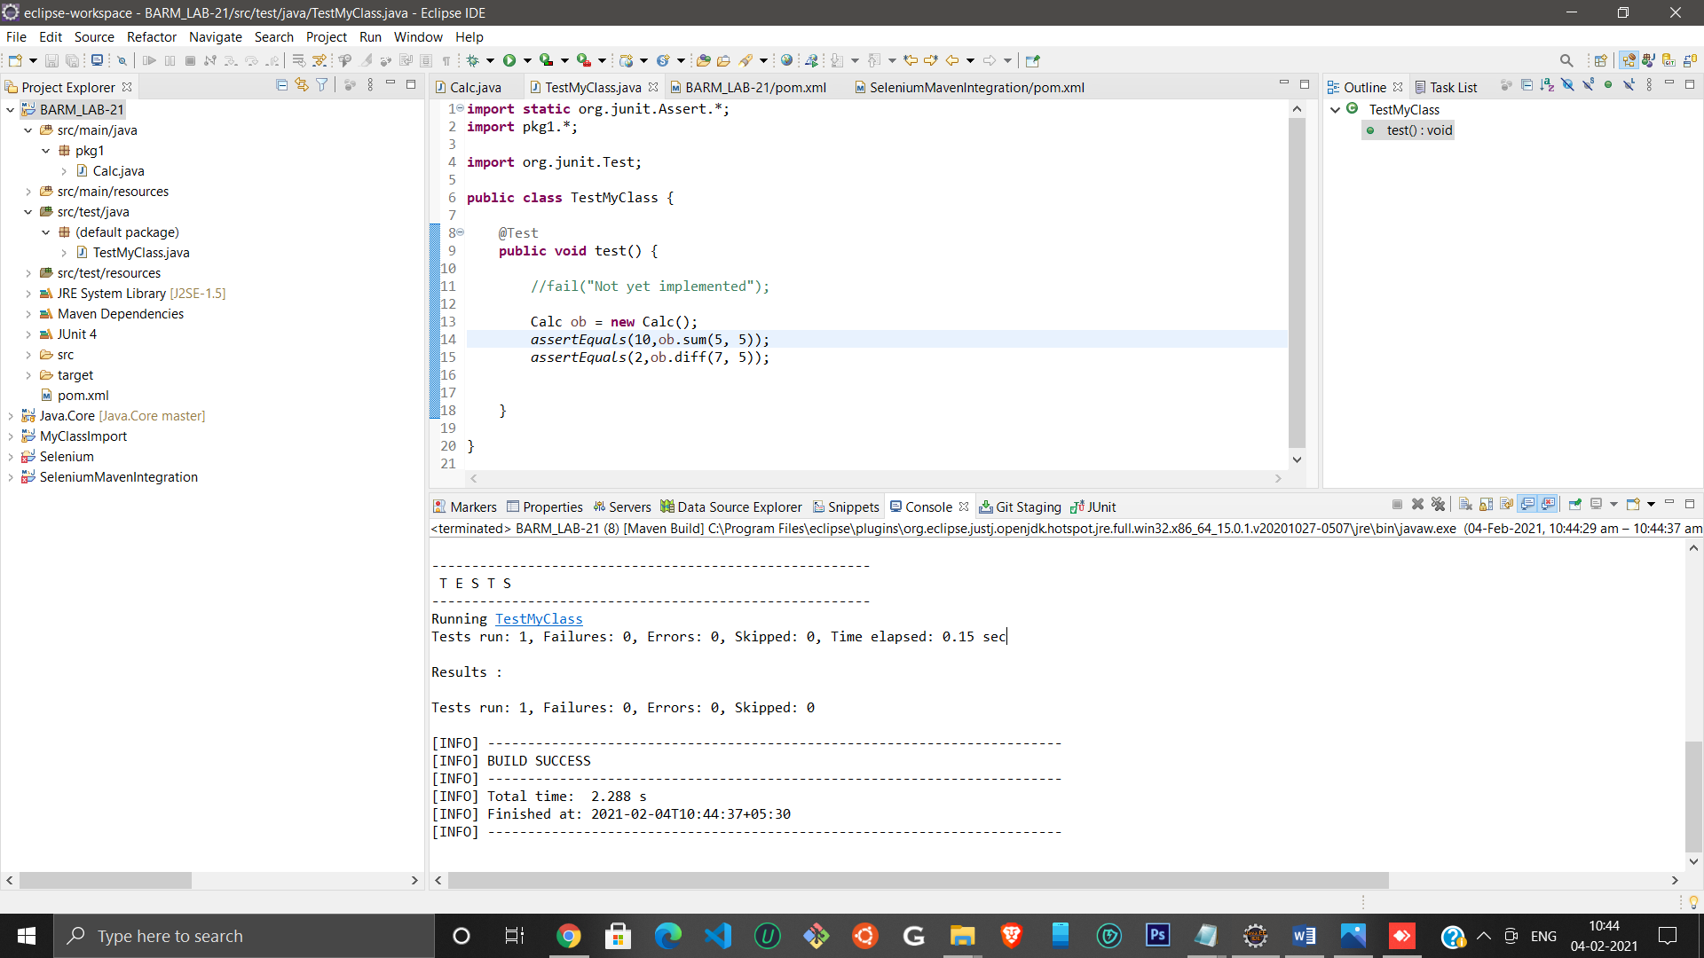

Build successful after test conditions are satisfied